Tel: (034) 329 7200
Fax: (034) 314 3785
e-mail:
admin@amajuba.gov.za
web page:
www.amajuba.gov.za
Private Bag 6615
Newcastle
2940
B9356, Amajuba Building, Section 1, Madadeni
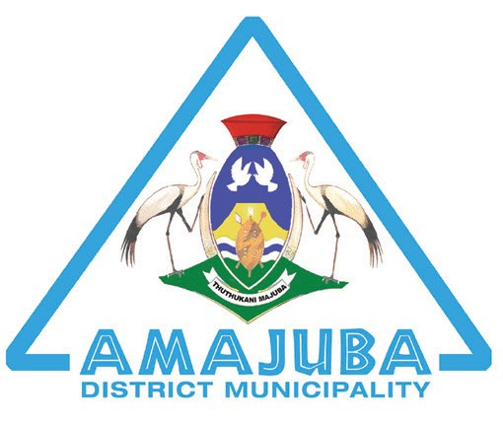

EXTRACT OF THE VIRTUAL COUNCIL MINUTES NO C/10/2019-2020 HELD ON TUESDAY 30 JUNE 2020 AT 12H00.

11. 2 DRAFT MEDIUM-TERM REVENUE AND EXPENDITURE FRAMEWORK (MTREF): 2020-2021 TO 2022/2023 FOR AMAJUBA DISTRICT MUNICIPALITY AS REQUIRED BY SECTION 16 OF THE MFMA

Upon presentation by Mayor, followed by engagements and comments by Councillors, it was

Proposed by Cllr JA Vorster and Seconded by Cllr D Ngwenya

RESOLVED C192:30/06/2020

    - THAT the Operating Expenditure Budget for the 2020/21 financial year amounting to R 277 974 121 as well as the appropriations for the outer years of the MTREF period of R 285 728 416 or the 2021/22 and R 298 913 047 for the 2022/23 financial years be approved;

    - THAT the Operating Revenue Budget for the 2020/21 financial year amounting to R 224 340 061 as well as the appropriations for the outer years of the MTREF period of R 236 541 122 or the 2021/22 and R 251 568 103 for the 2022/23 financial years be approved;

    - THAT Capital Budget allocation of R92 317 800 to be funded mainly from Municipal Infrastructure Grant (MIG) allocation and the Municipal Water Infrastructure Grant allocations be noted;

    - THAT the Water and Sanitation Tariff’s and other Minor Tariffs be approved at a 6% increase to be effective 1 July 2020 FY;

    - THAT the Operating Deficit of (R53 634 060) be noted;

    - THAT the MTREF 2020-2021_2023 Budget be approved; and

    - THAT EFF and DA dissenting vote be recorded.

Certified as true extract of the above minutes.

-------------------------------------------------- --------------------------------
SR ZWANE DATE
MUNICIPAL MANAGER

